**WAVE MOTION: MECHANICAL WAVES**

Wave ~ any disturbance from an equilibrium condition which travels or propagates with time from one region in space to another.

Ex: water waves and sound waves

Classifications of Waves

Mechanical waves - waves wherein the disturbance travel thru a material medium

Ex: sound waves - need a material medium to be transmitted

Electromagnetic waves - waves wherein the disturbance travel through empty space

Ex: radio waves, TV signals, microwaves, X-rays

Matter waves - associated with electrons, protons, and other fundamental particles, and even atoms and molecules

MECHANICAL WAVES

Types of mechanical waves:

1. Transverse waves - the particles vibrate perpendicular to the direction of the waves

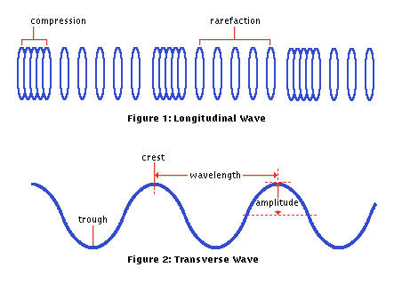Ex: waves traveling thru a stretched string, cord or wire

1. Longitudinal or Compressional Waves - the particles vibrate parallel to the direction of the waves

Ex: waves traveling thru liquids, air, metal bars or rod

* When longitudinal waves travel through a medium, there are alternate compression and rarefaction regions.

PROPERTIES OF WAVES:

1. Amplitude (A) - maximum displacement of a particle in the medium

2. Wavelength (λ) - distance between two (2) consecutive particles which are of the same phase (i.e. same displacement and same velocity)

3. Frequency (f) - number of vibrations made by each particle per second

4. Period (T) – time to complete one cycle

5. Speed of propagation (V) - the distance traveled by the particle in the medium per second

General Equation: **v = λf**

**MATHEMATICAL REPRESENTATION OF WAVE**

A wave cannot be analyzed completely unless its mathematical description or equation is used. Just like any other curve, a wave is also expressed by means of an equation. Ordinarily, the equation is a simple sine or cosine function but since it is a traveling wave, consideration is made on the distance it travels thru the medium during a time, t.

General Equation: **y(x,t) = Asin(kx ∓ ωt $±$ $∅$)**

where: A = amplitude

ω = 2πf = angular frequency

k = $\frac{2π}{λ}$ = wave number or propagation number

y = the displacement of a particle in the medium during a time t which is at a distance x from the source

(-) ωt = moving in the +x-direction

(+) ωt = moving in the –x-direction

∅ = phase angle

**STATIONARY (STANDING) WAVES**

Stationary or standing waves formed when two component waves (i.e. incident and reflected waves) of similar properties travel in opposite directions though the same medium.

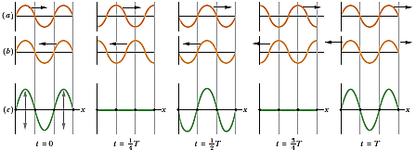

1. *Five snapshots of a wave traveling to the right, at the times t indicated below part (c) (T is the period of oscillation). (b) Five snapshots of a wave identical to that in (a) but traveling to the left, at the same times t. (c) Corresponding snapshots for the superposition of the two waves on the same string. At t = 0, ½ T, and T, fully constructive interference occurs because of the alignment of peaks with peaks and valleys with valleys*. *At t = 1/4T and 3/4T, fully destructive interference occurs because of the alignment of peaks with valleys.*

As the waves move through each other, some points never move (**nodes**) and some move the most (**antinodes**).

From the figure, we can derive a wave function for that specific standing wave by adding the wave functions y1(x, t) and y2(x, t):

where: y­1(x,t) = Asin(kx - ωt)

(incident wave traveling to the right)

y2(x,t) = Asin(kx+ ωt)

(reflected wave traveling to the left)

The principle of superposition gives, for the combined wave (stationary wave):

ys(x,t) = y1+y2 = Asin(kx - ωt) + Asin(kx + ωt)

*Review: cos(A±B) = cosAcosB ∓ sinAsinB

sin(A±B) = sinAcosB ± cosAsinB

ys(x,t) = A[sin(kx)cos(ωt)-cos(kx)sin(ωt)]

+ A[sin(kx)cos(ωt)+cos(kx)sin(ωt)]

ys(x,t) = 2Asin(kx)cos(ωt)

**ys(x,t) = ASWsin(kx)cos(ωt)**

magnitude - gives amplitude at position x

Asw = amplitude of the standing wave

**MODES OF VIBRATION**

* Modes – frequencies of waves associated with their wave

patterns

* Harmonics – a note of which the vibration rate is a whole

number

* a note whose frequency is a multiple of the fundamental frequency
* Overtone – a term preferred by musicians instead of

harmonics

1. ***Modes of Vibration of a String Fixed at Both Ends:***

Fundamental freq. or 1st harmonic freq.

2nd harmonic freq. or 1st overtone freq.

3rd harmonic freq. or 2nd overtone freq.

Since both ends of the string are fixed in position, the ends must be nodes in the standing waves; we can observe from the figures that the length L of the string must be an integer number of half wavelength.

For the fundamental frequency:

L = $\frac{λ}{2}$; λ = 2L and from v = λf; f = v/ λ

f1 =

For the general equation:

Let n = harmonic number

x= overtone number

n = x+1

**fn = nf1 =** , Hz n =1,2,3,4,5,…

But the ***VELOCITY*** of wave traveling thru vibrating strings, cords or wires is: **v = $\sqrt{\frac{T}{μ}}$**

where: T = tension on the string/cord/wire, Newton

μ = mass per unit length of the string

= m/L , kg/m

μ = linear density

= ρA where: ρ = density of string

= SG x mass density of water

A = cross-sectional area of string

**fn=**

Therefore:

*For string fixed at both ends, the harmonic number is the same as the number of segments.

1. ***Modes of Vibration of a Rod Clamped at One End:***

* It will always be a node at clamped end and an antinode at the free end.

Fundamental Freq. or 1st Harmonic Freq.

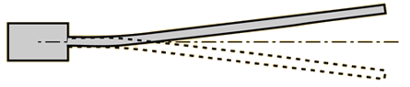

3rd Harmonic Freq. or 1st Overtone

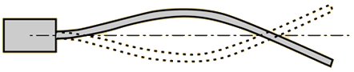

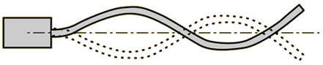5th Harmonic Freq. or 2nd Overtone

For the general equation:

Let n = harmonic no.

x = overtone no.

n = 2x + 1

**fn = nf1** or **,** Hz n = 1, 3, 5, 7, 9, …

The ***VELOCITY*** of wave traveling thru metal rods is:

**V = $\sqrt{\frac{Y}{ρ}}$** where: Y = Young's modulus of elasticity, Pa

ρ= density of rod or bar

Young's modulus of elasticity

Y = stress/strain

Stress = Force / cross-sectional area = F/A

Strain = elongation / original length = e/Lo

Y = $\frac{F/A}{e/Lo}$ **= $\frac{FL}{eA}$**

1. ***Modes of Vibration of a Rod Fixed at Midpoint:***

* It will always be a node at midpoint and antinode at the ends.

Fundamental Freq. or 1st Harmonic Freq.

3rd Harmonic Freq. or 1st Overtone

5th Harmonic Freq. or 2nd Overtone

For the general equation:

Let n = harmonic no.

x = overtone no.

n = 2x + 1

**fn = nf1** or **,** Hz n = 1, 3, 5, 7, 9, …

1. ***Modes of Vibration of an Air Column:***

Pipes can either be open on both ends or on only one end. The open ends act as free-end reflectors (producing antinodes) and the closed ends act as fixed-end reflectors (producing nodes).

1. 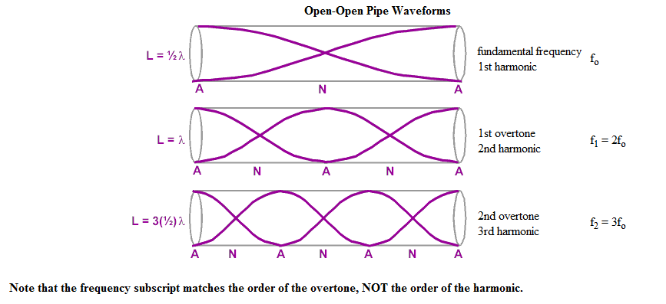OPEN PIPE

In general:

f = $\frac{v}{λ }$*L =λ/2, λ = 2L

f = v/2L

**fn =** n=1, 2, 3, 4, 5 ,...

For the general equation:

Let n = harmonic no.

x = overtone no.

n = x + 1

**fn = nf1** or **,** Hz n = 1, 2, 3, 4, 5, …

The ***VELOCITY*** of wave traveling thru air is:

**V = 332 + 0.6T** where: T = temperature in OC

1. 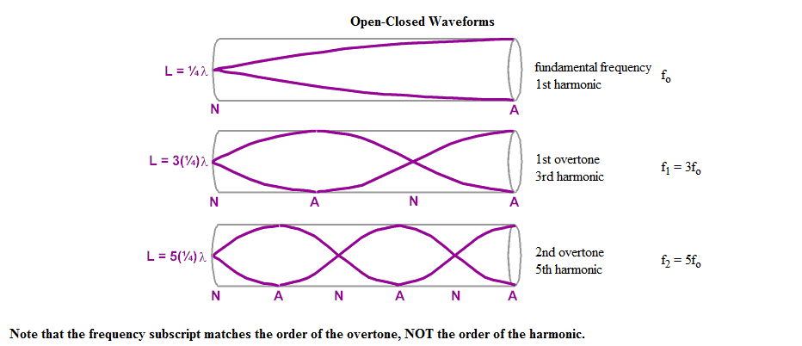CLOSED PIPE

For the general equation:

Let n = harmonic no.

x = overtone no.

n = 2x + 1

**fn = nf1** or **,** Hz n = 1, 3, 5, 7, 9, …

PROBLEMS:

1. A transverse wave on a string is described by the wave function

y = 0.120sin $(\frac{π}{8}x+4πt)$

where *x* and *y* are in meters and *t* is in seconds. Determine (a) the transverse speed and (b) the transverse acceleration at *t* = 0.2s for an element of the string located at *x =* 1.60 m. What are (c) the wavelength, (d) the period, and (e) the speed of propagation of this wave?

1. A sinusoidal wave of wavelength 2 m and amplitude 0.1 m travels on a string with a speed of 1 m/s to the right. At *t* = 0, the left end of the string is at the origin. For this wave, find (a) the frequency, (b) the angular frequency, (c) the angular wave number, and (d) the wave function in SI units. Determine the equation of motion in SI units for (e) the left end of the string and (f) the point on the string at *x* = 1.5 m to the right of the left end. (g) What is the maximum speed of any element of the string?
2. The wave function for a traveling wave on a taut string is (in SI units)

*y(x*, *t)* = 0.350 sin(10π*t* - 3π*x* + $\frac{π}{4}$)

(a) What are the speed and direction of travel of the wave? (b) What is the vertical position of an element of the string at *t* = 0, *x* = 0.1m? What are (c) the wavelength and (d) the frequency of the wave? (e) What is the maximum transverse speed of an element of the string?

1. Transverse waves on a string have wave speed 8m/s, amplitude 0.07m, and wavelength 0.32m. The waves travel in the negative x-direction, and at *t* = 0 the *x* = 0 end of the string has its maximum upward displacement. (a) Find the frequency, period, and wave number of these waves. (b) Write a wave function describing the wave. (c) Find the transverse displacement of a particle at *x* = 0.36m at time t = 0.15s.
2. Two sinusoidal waves traveling in opposite directions interfere to produce a standing wave with the wave function

*y* = 1.50 sin (0.400*x*) cos (200*t*)

where *x* and *y* are in meters and *t* is in seconds. Determine (a) the wavelength, (b) the frequency, and (c) the speed of the interfering waves.

1. Two transverse sinusoidal waves combining in a medium are described by the wave functions

*y*1 = 3.00 sin π(*x* + 0.600*t*) *y*2 = 3.00 sin π(*x* - 0.600*t*)

where *x*, *y*1, and *y*2 are in centimeters and *t* is in seconds. Determine the maximum transverse position of an element of the medium at (a) *x* = 0.250 cm, (b) *x* = 0.500 cm, and (c) *x* = 1.50 cm. (d) Find the three smallest values of *x* corresponding to antinodes.

1. A transverse traveling wave on a taut wire has an amplitude of 0.200 mm and a frequency of 500 Hz. It travels with a speed of 196 m/s. (a) Write an equation in SI units of the form y = A sin (kx - ωt) for this wave. (b) The mass per unit length of this wire is 4.10 g/m. Find the tension in the wire.
2. A 2-m-long wire having a mass of 0.1 kg is fixed at both ends. The tension in the wire is maintained at 20 N. (a) What are the frequencies of the first three allowed modes of vibration? (b) If a node is observed at a point 0.400 m from one end, in what mode and with what frequency is it vibrating?
3. A pipe open at both ends has a fundamental frequency of 300 Hz when the temperature is 0°C. (a) What is the length of the pipe? (b) What is its third harmonic frequency at a temperature of 30°C?
4. A string is 0.400 m long and has a mass per unit length of 9 x 10–3 kg/m. What must be the tension in the string if its second harmonic has the same frequency as the second resonance mode of a 1.75-m-long pipe (a) open at one end? (b) open at both ends?
5. An aluminum rod 1.60 m long is held at its center. It is stroked with a rosin-coated cloth to set up a longitudinal vibration. The speed of sound in a thin rod of aluminum is 5 100 m/s. (a) What is the fundamental frequency of the waves established in the rod? (b) What would be the fundamental frequency if the rod were copper, in which the speed of sound is 3 560 m/s?
6. A 1.2m long rod is fixed at midpoint and free at both ends. It produces a 2nd overtone of frequency 6000Hz. Solve for the speed of the wave.
7. A 2m long rod clamped at one end has a diameter 0.5cm and a specific gravity of 9. It elongates by 2mm when acted upon by a tensile force of 500N.
8. What is the speed of sound thru the rod?
9. What would be the frequency of the waves if the rod forms an equivalent of 3.5 segments every time?
10. Longitudinal standing waves are formed by a 1.2m long rod clamped at the center which has a density of 104 kg/m3 and a Young’s modulus of elasticity of 9x1010 Pa. Determine its 4th overtone frequency.